Ex. No. : 09 | Date:
Register No.: 231701501 | Name: Sri Vishnu K

KNN and K-Means
Aim:
To implement K-Nearest Neighbors (KNN) and K-Means clustering on the Iris dataset..
Program:
import pandas as pd
import numpy as np
import matplotlib.pyplot as plt

from google.colab import files
from sklearn.model_selection import train_test_split
from sklearn.preprocessing import LabelEncoder, StandardScaler
from sklearn.neighbors import KNeighborsClassifier
from sklearn.cluster import KMeans
from sklearn.metrics import accuracy_score, confusion_matrix, classification_report

# Upload dataset
uploaded = files.upload()

# Load dataset
data = pd.read_csv("Iris.csv")
# Drop Id column if present
if 'Id' in data.columns:
data = data.drop('Id', axis=1)
# Split features and target
X = data.iloc[:, :-1].values
y = data.iloc[:, -1].values
# Encode target labels
le = LabelEncoder()
y = le.fit_transform(y)
# ----------- KNN (Supervised Learning) -----------

# Train-test split
X_train, X_test, y_train, y_test = train_test_split(
X, y, test_size=0.2, random_state=42
)

# Feature scaling
scaler = StandardScaler()
X_train = scaler.fit_transform(X_train)
X_test = scaler.transform(X_test)

# Create KNN model
knn = KNeighborsClassifier(n_neighbors=5)

# Train model
knn.fit(X_train, y_train)

# Predictions
y_pred = knn.predict(X_test)

# Evaluation
print("KNN Results")
print("Accuracy:", accuracy_score(y_test, y_pred))
print("\nConfusion Matrix:\n", confusion_matrix(y_test, y_pred))
print("\nClassification Report:\n", classification_report(y_test, y_pred))

# ----------- K-Means (Unsupervised Learning) -----------

# Apply K-Means clustering
kmeans = KMeans(n_clusters=3, random_state=42, n_init=10)
kmeans.fit(X)

clusters = kmeans.labels_

# Visualization using first two features
plt.figure()
plt.scatter(X[:, 0], X[:, 1], c=clusters)
plt.xlabel("Sepal Length")
plt.ylabel("Sepal Width")
plt.title("K-Means Clustering on Iris Dataset")
plt.show()
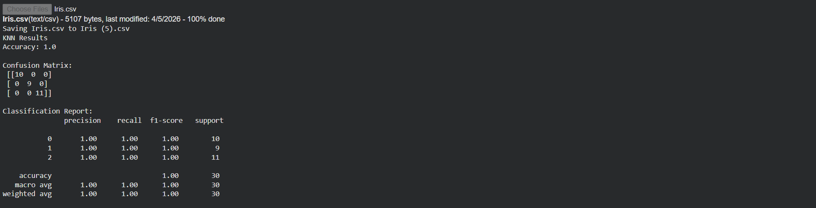

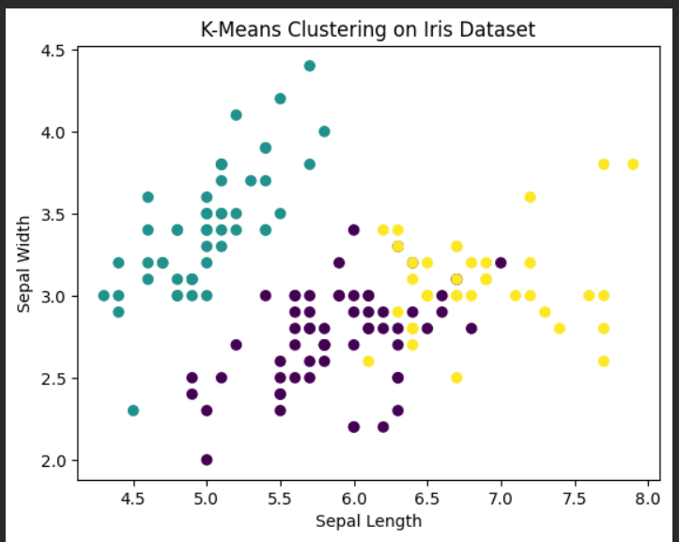

Result:
KNN successfully classified the Iris dataset with good accuracy. K-Means grouped the data into clusters representing different species.

